1-Home Location Register (HLR)

📒 What Is a Home Location Register (HLR)?
# Source: Chatgpt (GPT-5-Mini) at [1/23/2026]
The Home Location Register (HLR) is a central database in a mobile network that stores and manages subscriber information for users registered to that network. It is a critical part of GSM and 3G mobile systems.
📍 Think of the HLR as the “master record” of every subscriber’s identity, mobile number, and current network status.

🧩 What Does the HLR Store?
# Source: Chatgpt (GPT-5-Mini) at [1/23/2026]
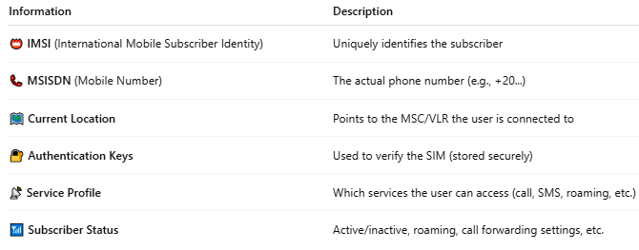

Information | Description
📛 IMSI (International Mobile Subscriber Identity) | Uniquely identifies the subscriber
📞 MSISDN (Mobile Number) | The actual phone number (e.g., +20...)
🗺️ Current Location | Points to the MSC/VLR the user is connected to
🔐 Authentication Keys | Used to verify the SIM (stored securely)
📡 Service Profile | Which services the user can access (call, SMS, roaming, etc.)
📶 Subscriber Status | Active/inactive, roaming, call forwarding settings, etc.

🔁 HLR’s Role in the Mobile Network:
# Source: Chatgpt (GPT-5-Mini) at [1/23/2026]
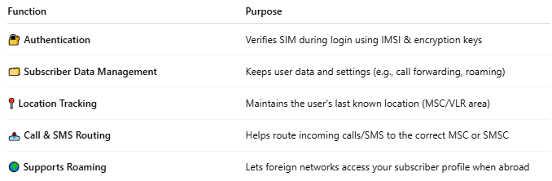

Function | Purpose
🔐 Authentication | Verifies SIM during login using IMSI & encryption keys
🗂️ Subscriber Data Management | Keeps user data and settings (e.g., call forwarding, roaming)
📍 Location Tracking | Maintains the user's last known location (MSC/VLR area)
📤 Call & SMS Routing | Helps route incoming calls/SMS to the correct MSC or SMSC
🌍 Supports Roaming | Lets foreign networks access your subscriber profile when abroad

📦 HLR in Action (Example Flow):
# Source: Chatgpt (GPT-5-Mini) at [1/23/2026]
You turn on your phone in Cairo:
- 📶 Your SIM sends its IMSI to the network.
- 🔐 The HLR is contacted to authenticate your SIM.
- 🗺️ HLR updates your location to the current VLR and MSC.
- 📞 When someone calls you, the HLR helps route the call to your current location.

🔁 HLR vs VLR:
# Source: Chatgpt (GPT-5-Mini) at [1/23/2026]
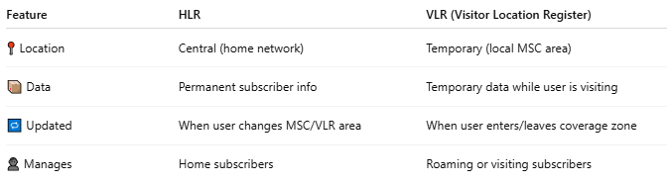

Feature | HLR | VLR (Visitor Location Register)
📍 Location | Central (home network) | Temporary (local MSC area)
📦 Data | Permanent subscriber info | Temporary data while user is visiting
🔁 Updated | When user changes MSC/VLR area | When user enters/leaves coverage zone
👤 Manages | Home subscribers | Roaming or visiting subscribers

📖 Summary:
# Source: Chatgpt (GPT-5-Mini) at [1/23/2026]
The Home Location Register (HLR) is the core database in GSM/3G networks that:
- Stores SIM identity, mobile number, and service profile
- Tracks where the subscriber is currently located
- Helps route calls and SMS
- Supports roaming and SIM authentication
It plays a central role in keeping you connected — whether you're at home or abroad.

2-Visitor Location Register

📘 What Is a VLR (Visitor Location Register)?
# Source: Chatgpt (GPT-5-Mini) at [1/23/2026]
The Visitor Location Register (VLR) is a temporary database in a mobile network that stores information about mobile subscribers currently located in its coverage area, even if they’re not from that area.
📍 It works like a local guest book that helps the network keep track of where a mobile user is, so calls and SMS can be delivered properly.

🧩 VLR in Simple Terms:
# Source: Chatgpt (GPT-5-Mini) at [1/23/2026]
- 🏡 HLR = "Home profile" (permanent info for each subscriber)
- 🛂 VLR = "Visitor profile" (temporary info while you're in a location)

🔁 What Does the VLR Do?
# Source: Chatgpt (GPT-5-Mini) at [1/23/2026]
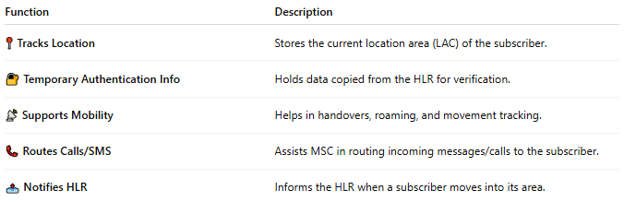

Function | Description
📍 Tracks Location | Stores the current location area (LAC) of the subscriber.
🔐 Temporary Authentication Info | Holds data copied from the HLR for verification.
📡 Supports Mobility | Helps in handovers, roaming, and movement tracking.
📞 Routes Calls/SMS | Assists MSC in routing incoming messages/calls to the subscriber.
📤 Notifies HLR | Informs the HLR when a subscriber moves into its area.

📦 VLR Stores:
# Source: Chatgpt (GPT-5-Mini) at [1/23/2026]
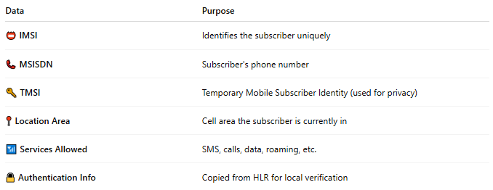

Data | Purpose
📛 IMSI | Identifies the subscriber uniquely
📞 MSISDN | Subscriber's phone number
🔑 TMSI | Temporary Mobile Subscriber Identity (used for privacy)
📍 Location Area | Cell area the subscriber is currently in
📶 Services Allowed | SMS, calls, data, roaming, etc.
🔒 Authentication Info | Copied from HLR for local verification

🔄 VLR in Action (Call/SMS Flow):
# Source: Chatgpt (GPT-5-Mini) at [1/23/2026]
- 📱 You turn on your phone in a new city.
- 🛰️ The local MSC/VLR requests your info from the HLR.
- 📘 VLR stores your profile temporarily.
- 📞 When someone calls you, the MSC queries the VLR.
- 📍 VLR knows where you are and forwards the call/SMS.

🧠 Relationship with MSC:
# Source: Chatgpt (GPT-5-Mini) at [1/23/2026]
- The VLR is tightly integrated with the MSC (Mobile Switching Center).
- Often runs on the same system or platform.
- VLR + MSC handle most call routing and subscriber mobility tasks.

🆚 VLR vs HLR:
# Source: Chatgpt (GPT-5-Mini) at [1/23/2026]
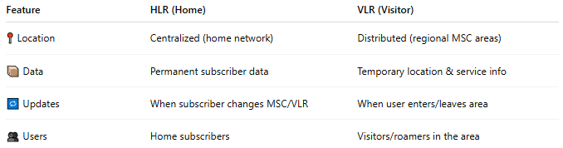

Feature | HLR (Home) | VLR (Visitor)
📍 Location | Centralized (home network) | Distributed (regional MSC areas)
📦 Data | Permanent subscriber data | Temporary location & service info
🔁 Updates | When subscriber changes MSC/VLR | When user enters/leaves area
👥 Users | Home subscribers | Visitors/roamers in the area

📖 Summary:
# Source: Chatgpt (GPT-5-Mini) at [1/23/2026]
The VLR (Visitor Location Register) is a temporary database used by mobile networks to:
- Track subscribers in a local area
- Assist with call and SMS routing
- Manage roaming and mobility
- Work alongside the HLR, MSC, and other systems
It ensures you stay reachable as you move across cities, countries, or networks.

